|  |  |  |  |
| --- | --- | --- | --- |
| 1000 rarb | **ADD** | RA,RB | ADD |
| 1001 rarb | **SHR** | RA,RB | Shift right |
| 1010 rarb | **SHL** | RA,RB | Shift left |
| 1011 rarb | **NOT** | RA,RB | NOT |
| 1100 rarb | **AND** | RA,RB | AND |
| 1101 rarb | **OR** | RA,RB | OR |
| 1110 rarb | **XOR** | RA,RB | Exclusive OR |
| 1111 rarb | **CMP** | RA,RB | Compare |

ALU instructions

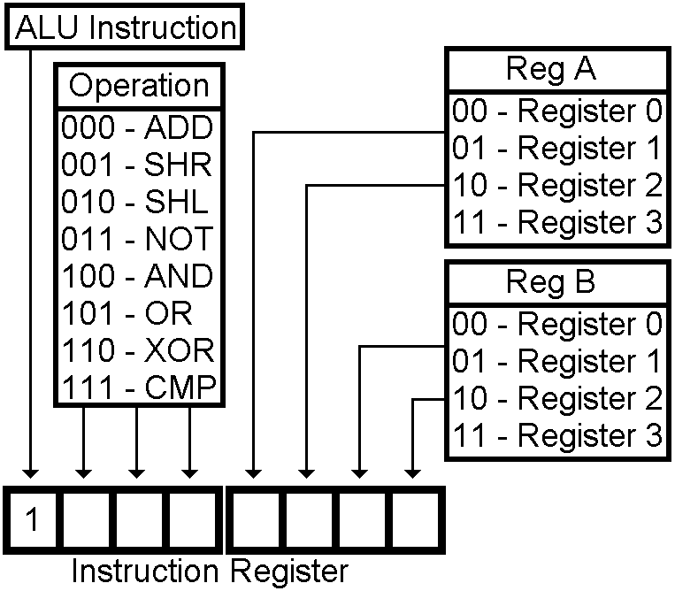

|  |  |  |  |
| --- | --- | --- | --- |
| 0000 rarb | **LD** | RA,RB | Load RB form RAM addr in RA |
| 0001 rarb | **ST** | RA,RB | Store RB to RAM addr in RA |
| 0010 00rb | **DATA** | RB, Addr | Load these 8 bits into RB |
| 0011 00rb | **JMPR** | RB | Jump to the address in RB |
| 0100 0000 | **JMP** | Addr | Jump to the addr in the next byte |
| 0101 caez | **JCAEZ** | Addr | Jump if any tested flag is on |
| 0110 0000 | **CLF** |  | Clear all flags |

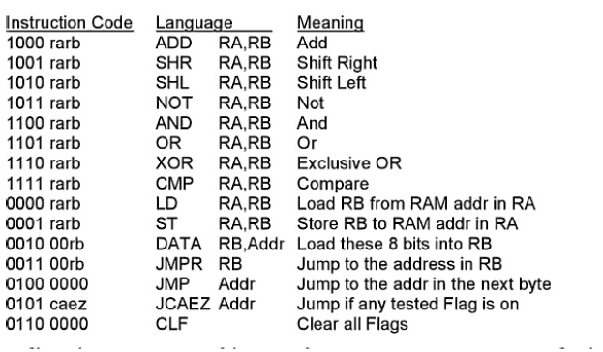

TABEL HOEF JE NEIT UIT JE HOOFD TE weten, maar je moet hem wel kunnen lezen.

